**A PRIVATE NEXTCLOUD SERVER ON FEDORA 34**

Nextcloud is a software suite of applications to store and sync files and data across multiple devices. It is a fully on-premises solution to share and collaborate on documents, manage your calendar and send and receive email.

Nextcloud gives you control and protection of your data while facilitating communication. It can enable productivity as you can access, sync, and share your existing data on an FTP drive across several connected devices at a home or office setup. Moreover, data privacy is critical, and running a private Nextcloud server is an excellent way to get started.

**INSTALLING A PRIVATE NEXTCLOUD SERVER ON FEDORA 34**

This tutorial will demonstrate how to install a private Nextcloud server on a Fedora 34 based server. We will install an Apache web server, PHP 7.4, and a MariaDB server and client as prerequisites.

**STEP 1. PREREQUISITES**

The first step is to satisfy the following prerequisites.

A server running Fedora. (I will use Fedora Workstation 34 for the demonstration)

A non-root sudo user.

Update your packages.

sudo dnf update

Essential packages and dependencies.  
Your system may already have some of these packages installed.

dnf install wget curl bzip2 nano unzip policycoreutils-python-utils -y

Note: if you have some prerequisites and packages already configured, then you can skip those steps.

**CONFIGURING FIREWALL IN FEDORA**

The first step is to configure the firewall from Firewalld through the command line. Note that Firewalld comes preinstalled in Fedora servers.

Check firewall status to ensure it is running:

sudo firewall-cmd --state

running

The next step is to allow HTTP and HTTPS ports.

Check allowed services and ports:

sudo firewall-cmd --permanent --list-services

dhcpv6-client mdns samba-client ssh

Allow HTTP and HTTPS ports.

sudo firewall-cmd --permanent --add-service=http

sudo firewall-cmd --permanent –add-service=https

Check allowed services and ports again.

sudo firewall-cmd --permanent --list-services

dhcpv6-client http https mdns samba-client ssh

Reload the firewall.

sudo systemctl reload firewalld

**INSTALL APACHE WEBSERVER**

Run the following command with sudo privileges to install the Apache webserver.

dnf install httpd

**INSTALL PHP**

The next step is to install PHP and other additional modules. If you already have PHP, make sure the PHP version meets Nextcloud’s requirements.

dnf install php php-gd php-mbstring php-intl php-pecl-apcu php-mysqlnd php-pecl-redis php-opcache php-imagick php-zip php-process

After PHP is installed, enable and start the Apache webserver:

systemctl enable --now httpd

Check if PHP is running.

php -version

PHP 7.4.19 (cli) (built: May 4 2021 11:06:37) ( NTS )

Copyright (c) The PHP Group

**INSTALLING MARIADB SERVER AND CLIENT**

MariaDB server is a drop-in replacement for MySQL, which means that commands to run and operate MariaDB and MySQL are the same.

Check if you have a default MariaDB server in your server or install it by running the following command.

dnf install mariadb mariadb-server

Enable and start the MariaDB server:

systemctl enable --now mariadb

Run the mysql_secure_installation command to secure your MariaDB server.

The command will perform default configurations setting the root password, removing anonymous users, disallowing root login remotely, and dropping test tables.

sudo mysql_secure_installation

[sudo] password for tuts:

Securing the MySQL server deployment.

Enter the password for user root:

The 'validate_password' component is installed.

>> The subsequent steps will run the existing configuration

of the component.

>> We are using an existing root password

Estimated strength of the password: 100

Change the password for root? ((Press YY | Y for Yes, any other key for No) :

>>

By default, a MariaDB server installation has an anonymous user

>>> is intended only for testing.

Remove anonymous users? (Press Y y | Y for Yes, any other key for No) : y

Success.

Normally, 'root' should only be allowed to connect from

'localhost.' This ensures that someone cannot guess

the root password from the network.

(ensure you read this policy while installing MariaDB server)

Disallow root login remotely? (Press Y y | y Y for Yes, any other key for No) : Y y

Success.

>>> (removing test database)

Remove test database and access to it? (Press Y y | Y for Yes, any other key for No) : y

>>> Dropping test database.

Success.

>>> Removing privileges on test database.

Success.

Reload privilege tables now? (Press Y y | Y for Yes, any other key for No) : y

Success.

All done!

Create a dedicated user and database for the Nextcloud server.

mysql -p

Create the ‘nextcloud’ database.

mysql> create database nextcloud;

Create a dedicated MySQL user to handle the ‘nextcloud’ database

mysql> create user 'nextclouduser'@'localhost' identified by 'SeCrEttErCeS';

Grant all privileges to the database (nextcloud) to the user (nextclouduser) we created.

mysql> grant all privileges on nextcloud_db.* to 'nextclouduser'@'localhost';

Flush privileges for the changes you have made to take effect.

mysql> flush privileges;

Quit the MySQL Shell.

mysql> exit;

Configure SELinux permissions

You must configure SELinux/permissions to work with Nextcloud.  
Run the following commands for your basic SELinux settings. These should work with your installation.

Make sure to adjust the file paths appropriately as per your system. Just in case they are different.

semanage fcontext -a -t httpd_sys_rw_content_t '/var/www/html/nextcloud/config(/.*)?'

semanage fcontext -a -t httpd_sys_rw_content_t '/var/www/html/nextcloud/apps(/.*)?'

semanage fcontext -a -t httpd_sys_rw_content_t '/var/www/html/nextcloud/data(/.*)?'

semanage fcontext -a -t httpd_sys_rw_content_t '/var/www/html/nextcloud/.user.ini'

semanage fcontext -a -t httpd_sys_rw_content_t '/var/www/html/nextcloud/3rdparty/aws/aws-sdk-php/src/data/logs(/.*)?'

# restorecon -Rv '/var/www/html/nextcloud/'

You can learn more SELinux commands that work with Nextcloud at Nextcloud SELinux configuration.

**STEP 2. INSTALLING NEXTCLOUD SERVER**

Our second step is to download and install Nextcloud. Head over to the official website and copy the download link of the zip file.  
Download and unzip the Nextcloud archive using wget. Make sure to paste the copied link after wget in the below command.

wget https://download.nextcloud.com/server/releases/nextcloud-21.0.2.zip

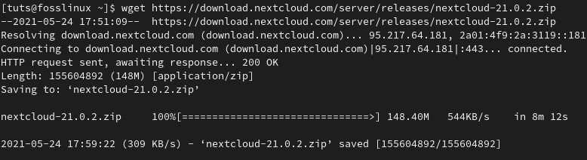Nextcloud archive

Unzip the archive to the ‘/var/www/html/’ directory.

unzip nextcloud-21.0.2.zip -d /var/www/html/

The next step is to grant Apache read and write access to the Nextcloud directory tree:  
Create a data folder in ‘/var/www/html/nextcloud/’ directory.

mkdir /var/www/html/nextcloud/data

Grant Apache read and write access using Chown.

chown -R apache:apache /var/www/html/nextcloud

Step 3. Configuring Nextcloud server

You can configure Nextcloud via the web interface or the command line.

Method 1: web interface

Access ‘http://your_server_ip/nextcloud’ from your web browser.  
In our case, the server is running from the localhost;

http://localhost/nextcloud

or

http://127.0.0.0/nextcloud

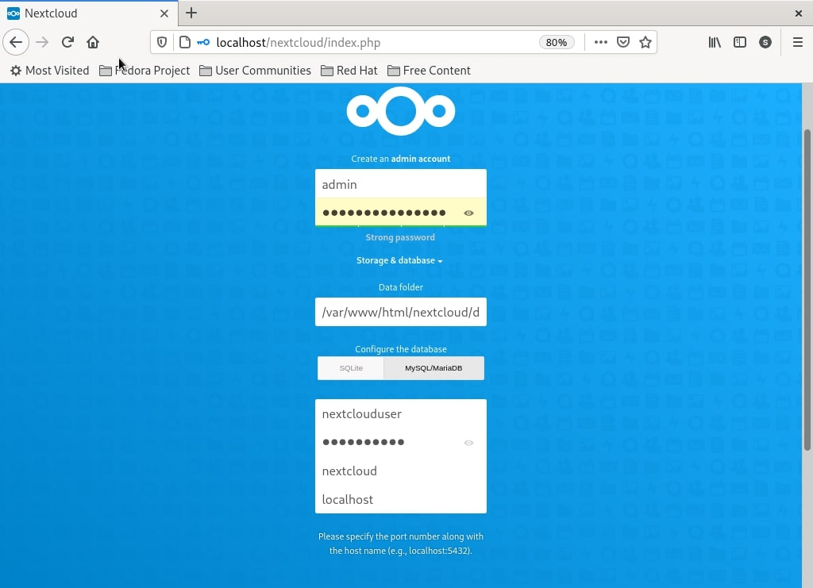Nextcloud config details

**METHOD 2: COMMAND-LINE**

Run the following command to configure Nexcloud from the command line.

sudo -u apache php occ maintenance:install --data-dir /var/www/html/nextcloud/data/ --database "mysql" --database-name "nextcloud" --database-user "nextclouduser" --database-pass "SeCrEttErCeS" --admin-user "admin" --admin-pass "AdMin_PAssWOrd"

Enter your administration login details and configure Nextcloud for first use.

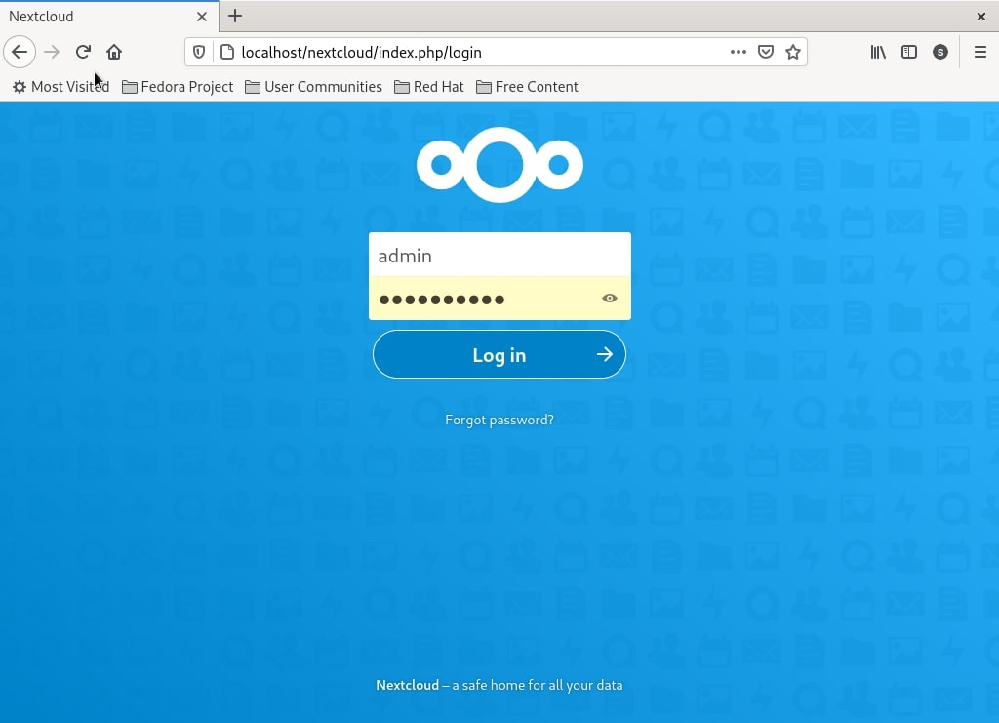  
Nextcloud admin login

Wrapping up

The recommend PHP memory limit for Nextcloud is 512M. You can edit the memory_limit variable in the /etc/php.ini configuration file and restart your httpd service.

Security is critical, and you should always configure SELinux rather than disabling it. It’s not a good idea to disable SELinux. The recommended practice is to always have it in enforcing mode.

That concludes our demonstration on installing a private Nextcloud server on Fedora 34 server.

If you run into any challenges or problems, feel free to ask or add a comment.